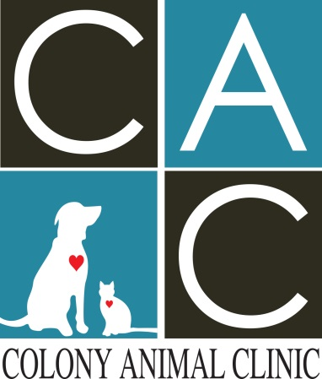
Adult Feline Yearly Schedule

Feline Wellness Visit- Outdoor (age 1-8 yrs of Age)
-Examination
-Intestinal Parasite Deworming
-FVRCP Booster
-Rabies Booster
-Feline Leukemia Booster
Feline Wellness Visit –Inside Only (1-8 yrs of age)
-Examination
-Intestinal Parasite Deworming
-FVRCP Booster
-Rabies Booster

Cats 8 years of age and older, certain purebred cats or cats with previously diagnosed medical conditions may receive additional labs. The breakdown is as followed:
Feline wellness visit basic lab- CBC, CHEM 10 and electrolytes
Feline wellness visit comprehensive lab- CBC, CHEM 17, electrolytes and urinalysis
Feline wellness visit comprehensive T4 lab- CBC, CHEM 17, electrolytes, urinalysis and thyroid check

**All felines will receive the basic package checks. The additional labs will be decided on by the Veterinarians and client at the time of appointment.

